H.T No
Regulations:
A15

Sreenidhi Institute of Science and Technology
(An Autonomous Institution)
Code No: 5FC09 Date: 07-Oct-2020 (AN)

B.Tech III-Year I-Semester External Examination, October - 2020 (Supplementary)
Web Technologies (CSE and IT)

Time: 2 Hours Max.Marks:75

Note: a) No additional answer sheets will be provided.
b) All sub-parts of a question must be answered at one place only, otherwise it will not be valued.
c) Missing data can be assumed suitably.

ANSWER ANY FIVE QUESTIONS. EACH QUESTION CARRIES 15 MARKS.

1. | a) | Define CSS and explain in detail different types of cascading styles sheets with examples. | [8M]
 | b) | Design the following Nested List using HTML  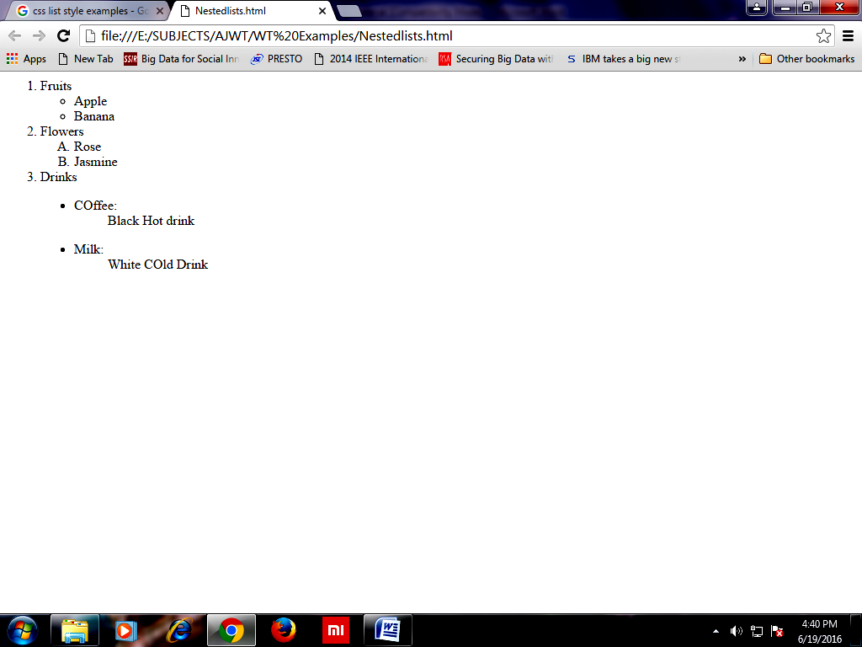 | [7M]
2. | a) | What is an Event? Explain how events are handled in JavaScript with an Example. | [8M]
 | b) | Write a JavaScript code to Print all numbers from 1 to 100 except multiples of 3. | [7M]
3. | a) | Define DTD. Design External DTD for the following XML file:  Student.xml :  <student>  <rollno>10</rollno>  <personalinfo>  <name>CSE</name>  <address>GEC</address>  </personalinfo>  <class>3rd Year</class>  <subject id="CS01">Web Technologies</subject>  <grade>O</grade>  </student> | [8M]
 | b) | Distinguish between DOM and SAX Parsers. | [7M]
4. | a) | Explore javax.servlet.http package | [8M]
 | b) | Explain with an example how to read Initialization Parameters stored in web.xml file using ServletConfig interface | [7M]
5. | a) | Discuss the Anatomy of a JSP Page | [8M]
 | b) | Illustrate with an example sharing data between pages using Session/Application Object. | [7M]
6. | a) | Draw the architectures of various JDBC Drivers and explain. | [8M]
 | b) | Write a JSP program to display employee details stored in the Database. | [7M]
7. | a) | Illustrate the use of Forms in Web Page. Explain the following form controls with example.  - Text Field  - Check Box  - Password Field  - Buttons | [8M]
 | b) | Write the importance of Hypertext and Hypertext markup language. | [7M]
8. | a) | Explain various control statements available with JavaScript with examples. | [8M]
 | b) | Write a Java script program to demonstrate the usage of function declaration. | [7M]

-- 00 -- 00 –

